**ASSIGNMENT 2**

## **Group Members:**

➢ **Smile Smile(200563908)**

**➢ Dev Dev(200562142)**

**➢ Robin Robin(200571744)**

❖ Github Link : https://github.com/gillr5070/frameworkAssignment2.git

**Assignment**: Importing and Using Custom Modules in Node.js

**Objective:**

To practice creating and importing your own modules in Node.js using ES modules.

**Instructions:**

Create two separate JavaScript files that will be run server-side using Node.js.

File 1 (Entry Point)

Name whatever you like.

Import and invoke functions from the second file using ES module syntax.

If you feel like it, use CommonJS syntax in a sister folder to compare and contrast.

File 2 (Utilities File)

Store functions, objects, or data to be used by the entry file. Create at least four functions: Print Function: takes a text input (two or three parameters) and prints out a formatted message. Example: greet("John", "Doe") → "Welcome John Doe to G@I College" Unit Converter: converts one unit of measurement to another, such as Celsius to Fahrenheit or minutes to hours. Math Function: does some math on numeric input, such as factorial, square root, etc.

Advanced Function: Complex function on input of your choice.

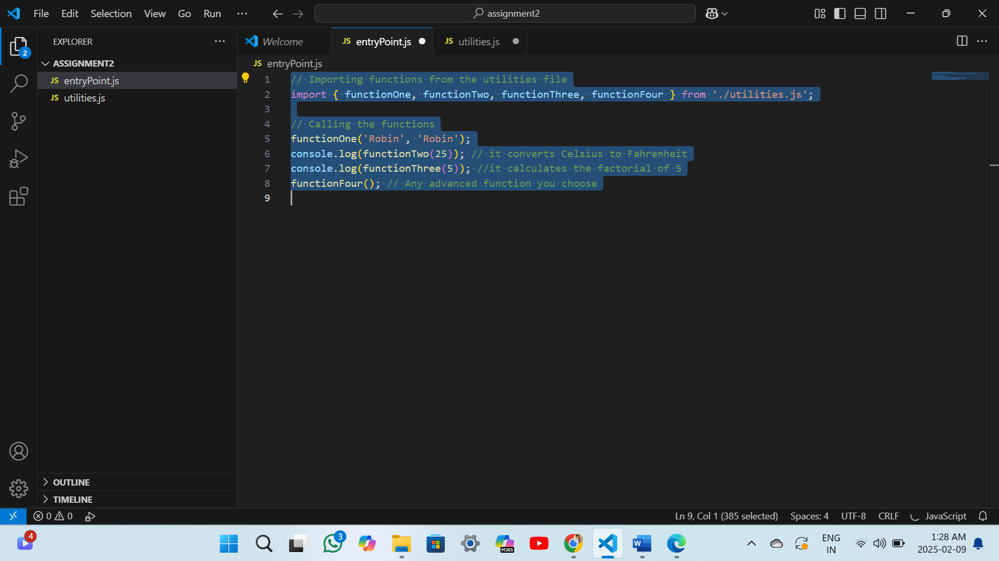

The script imports four functions from utilities.js and executes them. The first function prints a welcome message using provided names. The second converts 25°C to Fahrenheit, while the third calculates the factorial of 5. Finally, the fourth function runs a custom advanced operation.

There are four functions in the `utilities.js` file. The first function uses two name arguments to produce a welcome message. In the second, Celsius is converted to Fahrenheit. The third determines a given number's factorial. The area of a rectangle with specified dimensions is calculated and printed by the fourth.

To process entryPoint.js, which is a node entryPoint.js, simply enter this code in the terminal.

In conclusion, this assignment demonstrates the use of custom modules in Node.js by importing and executing functions from a separate file. It showcases fundamental programming concepts such as string manipulation, unit conversion, mathematical calculations, and an advanced function. This approach enhances modularity, code reusability, and better organization in JavaScript applications.